**The 2025 Henley Youth Festival Art Competition is now open.**

**Create a piece of art that reflects the 2025 theme:**

**Growing!**

**Paint, draw, photograph, make a collage, and sculpt in paper, clay, wood or any other medium. Mix your media if you wish.**

Think big – or small – or somewhere in between, (but ideally no bigger than 1m x 1m). Work on your own, or in a group. Have a look at the theme text on the Henley Youth Festival homepage for inspiration if you need it but the best ideas are your own.

If you’re bursting with imagination why not enter our writing competition as well? If you want to try your hand at music composition or a piece of performance art, please see separate competition guidelines and the Performing Arts entry forms at www.hyf.org.uk.

**Prizes**

Entries will be judged on imagination, creativity, innovation and interpretation of the theme and will be adjudicated by professional artists. Prizes will be awarded at an “invite only” presentation, Saturday 15 March 2025 at Henley Town Hall.

**Who can enter**  
Anyone is eligible to enter if you attend / live in the catchment area for one of the following participating schools: Badgemore; Bishopswood; Gillotts; Kidmore End; Nettlebed; Peppard; Sacred Heart; Shiplake; Sonning Common; Trinity; Valley Road; OR attend Henley College; Shiplake College; Chiltern Edge; Rupert House; St Mary’s. If you have changed schools to one not on the list, but have previously taken part in the Youth Festival please contact Charlene Brown on 07803 612175.

**Age Categories**

There are currently 3 categories:

**Infant (up to age 6 years) Junior (age 7 to 11) Senior (age 12 to 18)**

These categories may be subdivided depending upon the number of entries at the sole discretion of the organisers.

Plus **Collaborative** i.e. Art Clubs and other groups.

**How to enter**

Register your entry on the [online registration form](https://docs.google.com/forms/d/1Foqojz2w7bzbRJNv16Dno_E2d1lYQp86T1ygCze-bvA/edit) and then print out and fill in the artwork form below and attach to your piece of artwork carefully. For **film entries** see separate Film Entry form.

You should take your artwork to your School or College reception by **Tuesday 25 February (morning)** where it will be collected or you may drop off at The Lawns, Mill Lane Henley-on-Thames RG9 4HB.

**Closing date for all entries – Tuesday 25 February 2025**

**We need your details, so please follow these instructions:**

**Individual Submissions**1. Fill in the [online registration form](https://docs.google.com/forms/d/1Foqojz2w7bzbRJNv16Dno_E2d1lYQp86T1ygCze-bvA/edit).  
2. Print out and fill in the artwork form below carefully.    
3.  Paste to the back of your artwork   
4.  Please also write your name on the back of artwork.    
5.  Hand in to your School/College for collection, **OR** deliver to: The Lawns, Mill Lane, Henley on Thames, RG9 4HB by **Tuesday 25 February 2025.**

**School Submissions**

Please complete the instructions for the Individual Submissions. In addition, where entire classes are submitting artwork. Please also send along a Word document listing Each child’s name, age, Title of artwork and school

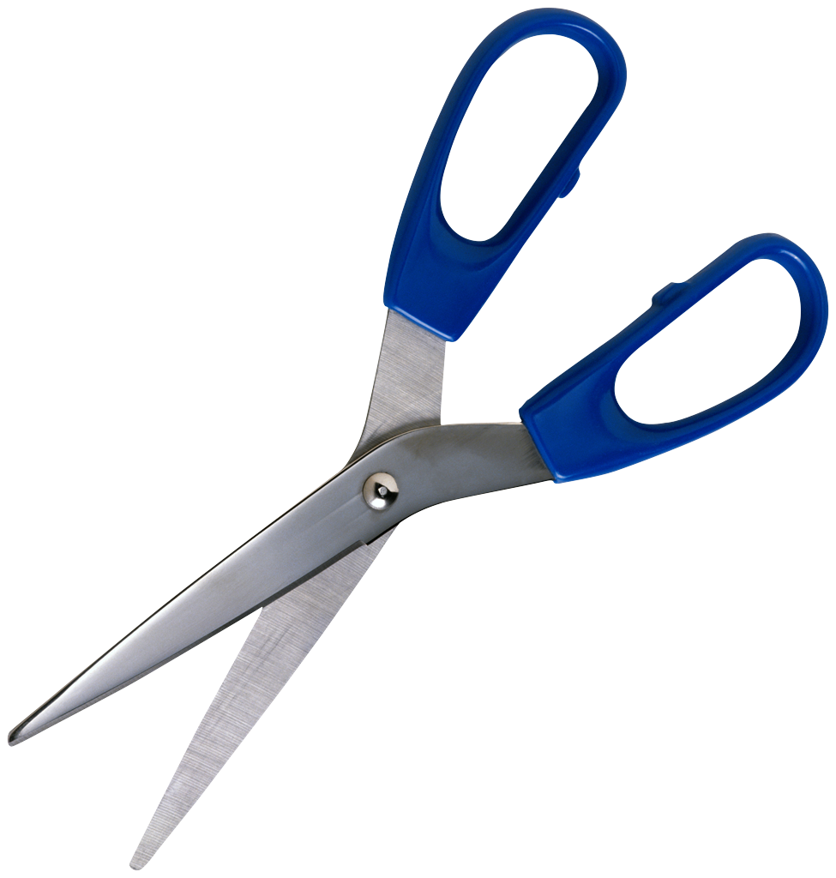

**----------------------------------------------------------------------------------------------------**    
**PLEASE PASTE TO THE BACK OF YOUR ARTWORK**

**Name.......................................................................................................................Age...................................  
   
School/College..................................................................................................................................................  
   
Address.............................................................................................................................................................  
   
Tel. Nos………………………………………………… Email ................................................................................................  
   
Title of Art Work .............................................................................................................................................**